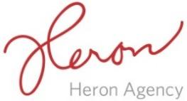
September Content Calendar 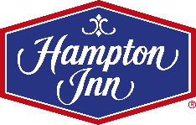
End of August | Facebook | Twitter | Instagram
Monday  8/22 | Check this out! As some of you may know, we have a 1928 Ford Model A in our hotel. Come stay with us and see for yourself!  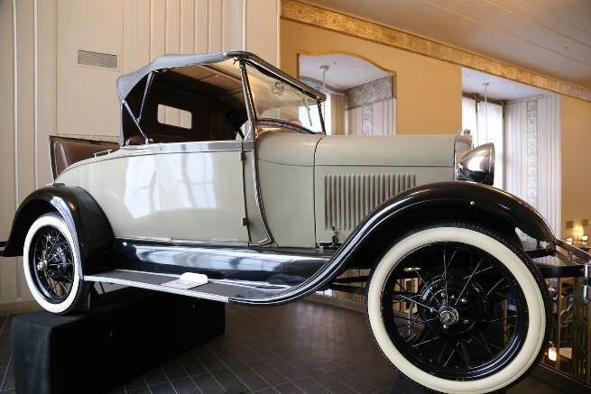 | Check this out! As some of you may know, we have a 1928 Ford Model A in our hotel. Come stay with us and see for yourself! | Check this out! As some of you may know, we have a 1928 Ford Model A in our hotel. Come stay with us and see for yourself!
Wednesday  8/24 | Looking to have a good time in Chicago without the price? We have the answer for you! Check out this list from, @Thrillist! http://bit.ly/27pX3vb  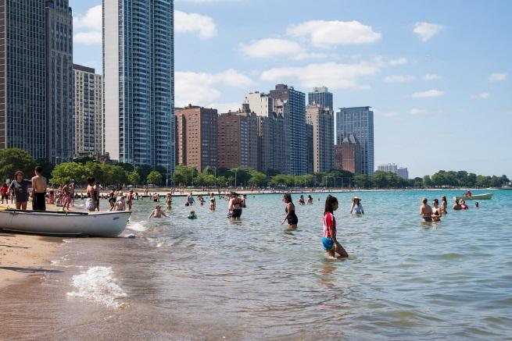 | Looking to have a good time in Chicago without the price? We have the answer for you! Check out this list from, @Thrillist! http://bit.ly/27pX3vb | Looking to have a good time in Chicago without the price? We have the answer for you! Check out this list from, @Thrillist! http://bit.ly/27pX3vb
Friday  8/26 | To a city that keeps growing, we love you Chicago! 1973, Chicago. #flashbackfriday  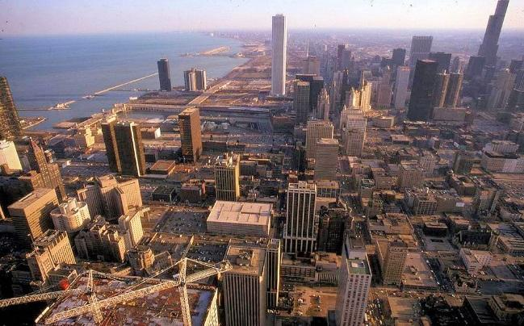 | To a city that keeps growing, we love you Chicago! 1973, Chicago. #flashbackfriday | To a city that keeps growing, we love you Chicago! 1973, Chicago. #flashbackfriday
Week 1 | Facebook | Twitter | Instagram
Monday  8/29 | Did You Know: The map displayed on the wall in our lobby is the original map that was displayed in the Chicago Motor Club Building!  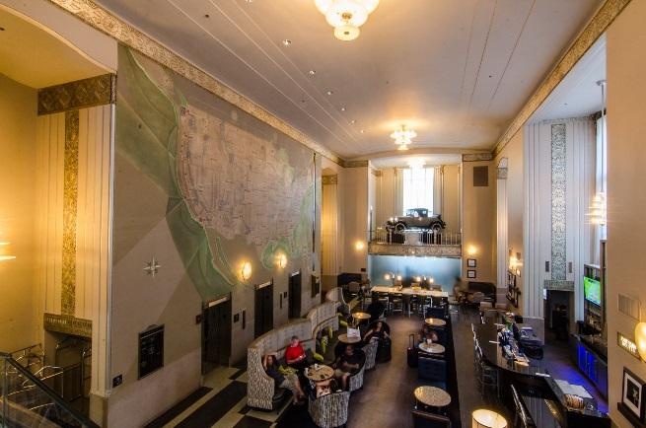 | Did You Know: The map displayed on the wall in our lobby is the original map that was displayed in the Chicago Motor Club Building! | Did You Know: The map displayed on the wall in our lobby is the original map that was displayed in the Chicago Motor Club Building!
Wednesday  8/31 | Add a little throwback to your Hump Day and come on over to Jack’s Place and try our 1920s inspired drink, Giggle Water. You will not be sorry!  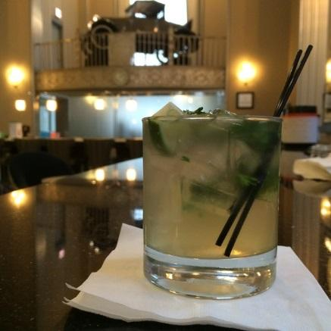 | Add a little throwback to your Hump Day and come on over to Jack’s Place and try our 1920s inspired drink, Giggle Water. You will not be sorry! | Add a little throwback to your Hump Day and come on over to Jack’s Place and try our 1920s inspired drink, Giggle Water. You will not be sorry!
Friday  9/2 | September is here, Chicago! How do you plan on spending this in between season?! Check out this list of activities and events going on in the city next month! http://www.events12.com/chicago/september  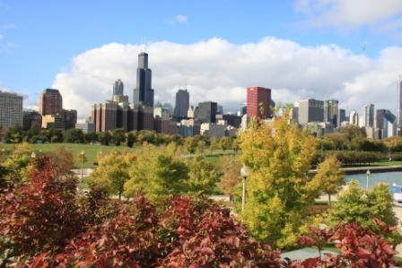 | September is here, Chicago! How do you plan on spending this in between season?! Check out this list of activities and events going on in the city next month! http://www.events12.com/chicago/septemb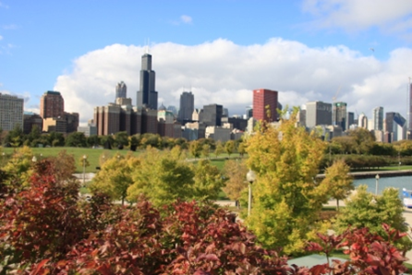er | September is here, Chicago! How do you plan on spending this in between season?! Check out this list of activities and events going on in the city next month! http://www.events12.com/chicago/september
Week 2 | Facebook | Twitter | Instagram
Monday  9/5 | Happy Labor Day from Hampton! We hope everyone spending their day relaxing and enjoying time with friends and family!  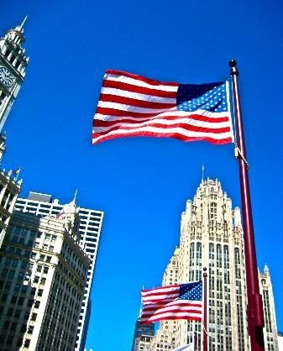 | 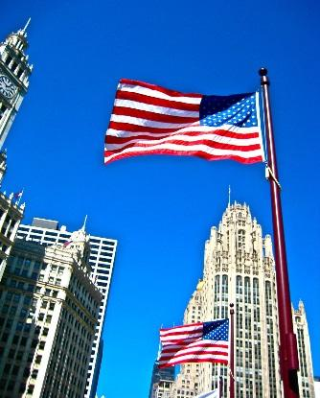  Happy Labor Day from Hampton! We hope everyone spending their day relaxing and enjoying time with friends and family! | Happy Labor Day from Hampton! We hope everyone spending their day relaxing and enjoying time with friends and family!
Wednesday  9/7 | Who said festival season needed to end in the summer? Here’s a full list from Time Out on all the festivals going on in Chicago this September. http://bit.ly/2a9eV7o  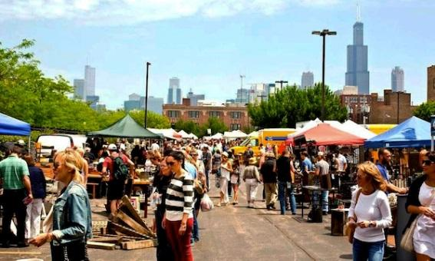 | 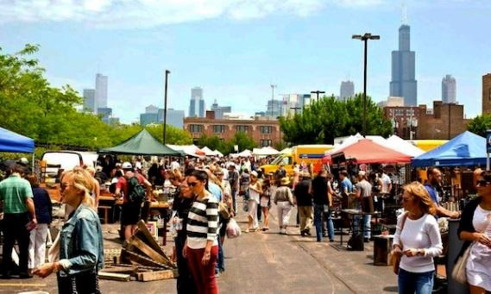  Who said festival season needed to end in the summer? Here’s a full list from Time Out on all the festivals going on in Chicago this September. http://bit.ly/2a9eV7o | Who said festival season needed to end in the summer? Here’s a full list from Time Out on all the festivals going on in Chicago this September. http://bit.ly/2a9eV7o  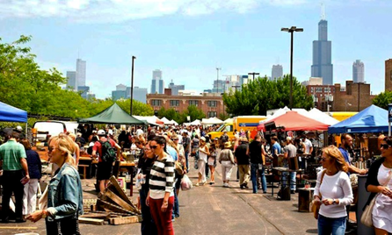
Friday  9/9 | The streets of #Chicago have always been a bustling place! Even with those #vintagecars in the middle of it all. #flashbackfriday  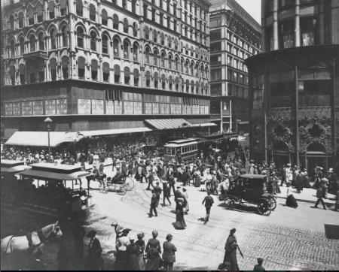  1905, State and Madison. | The streets of #Chicago have always been a bustling place! Even with those #vintagecars in the middle of it all. #flashbackfriday  1905, State and Madison. | The streets of #Chicago have always been a bustling place! Even with those #vintagecars in the middle of it all. #flashbackfriday  1905, State and Madison.
Week 3 | Facebook | Twitter | Instagram
Monday  9/12 | We’ve got a plan for you, Chicago visitors! Visit the Windy City this month, stay with us, and check out these great tips from USA Today! http://usat.ly/2bo2OGI  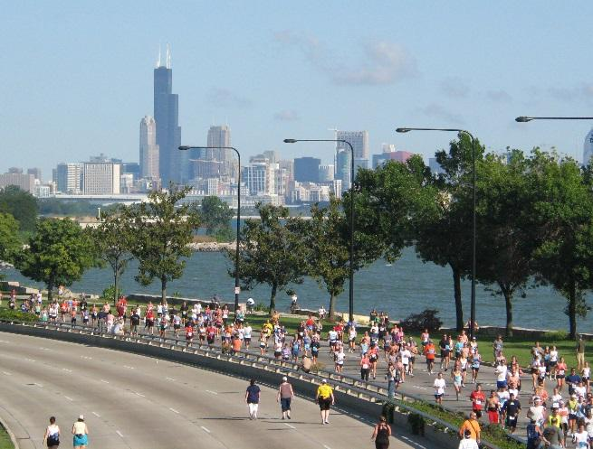 | We’ve got a plan for you, Chicago visitors! Visit the Windy City this month, stay with us, and check out these great tips from USA Today! http://usat.ly/2bo2OGI | We’ve got a plan for you, Chicago visitors! Visit the Windy City this month, stay with us, and check out these great tips from USA Today! http://usat.ly/2bo2OGIhtml
Wednesday  9/14 | #Revtoberfest is here! Join us today as we tap @RevBrewChicago's Oktoberfest. We have keep-the-stein specials, Rev Brew seasonal swag, and ticket giveaways to the Rev Oktoberfest party at the Kedzie Brewery. We hope to see you here!  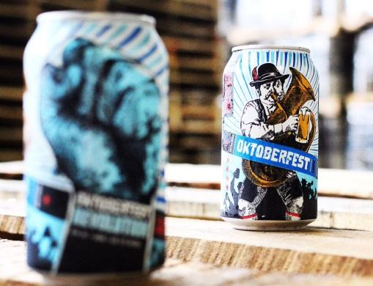 | #Revtoberfest is here! Join us today as we tap @RevBrewChicago's Oktoberfest. We have keep-the-stein specials, Rev Brew seasonal swag, and ticket giveaways to the Rev Oktoberfest party at the Kedzie Brewery. We hope to see you here! | #Revtoberfest is here! Join us today as we tap @RevBrewChicago's Oktoberfest. We have keep-the-stein specials, Rev Brew seasonal swag, and ticket giveaways to the Rev Oktoberfest party at the Kedzie Brewery. We hope to see you here!
Friday  9/16 | Announcing our participation in @ChiArchitecture's Open House Chicago! Oct 15-16. #OHC2016 Learn more: http://openhousechicago.org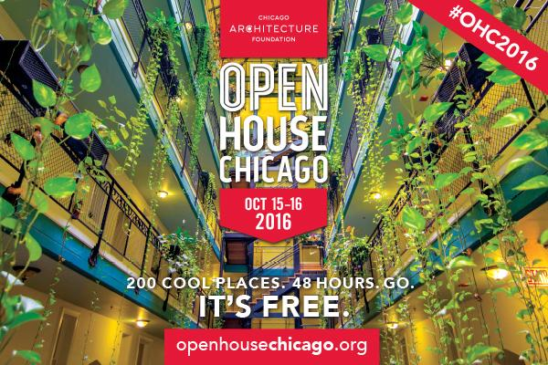 | Announcing our participation in @ChiArchitecture's Open House Chicago! Oct 15-16. #OHC2016 Learn more: http://bit.ly/1kLttVi | Announcing our participation in @ChiArchitecture's Open House Chicago! Oct 15-16. #OHC2016 Learn more: http://openhousechicago.org  #ChiArchitecture #Chicago

Week 4 | Facebook | Twitter | Instagram
Monday  9/19 | Looking for a place to host your next business meeting? With our prime central location in Downtown Chicago, we serve as a quintessential venue for companies to book their meeting room. Call our office at 1.312.419.9014 for more information and to book your room!  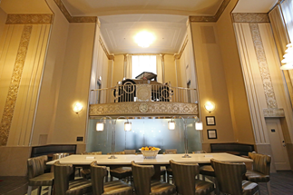 | Looking for a place to host your next business meeting? With our prime central location in Downtown Chicago, we serve as a quintessential venue for companies to book their meeting room. Call our office at 1.312.419.9014 for more information and to book your room! | Looking for a place to host your next business meeting? With our prime central location in Downtown Chicago, we serve as a quintessential venue for companies to book their meeting room. Call our office at 1.312.419.9014 for more information and to book your room!
Wednesday  9/21 | Wine down this Wednesday the right way. Head over to Jack’s Place and celebrate the middle of the week the best way we know how – with wine! #winewednesday  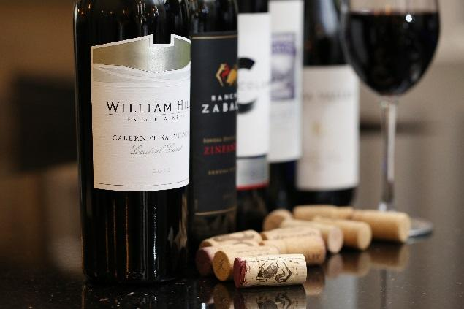 | 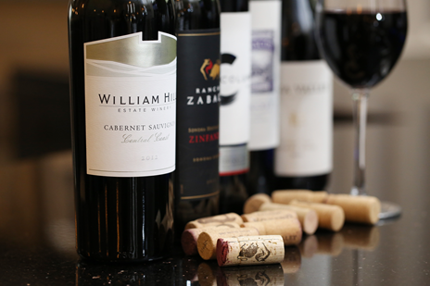  Wine down this Wednesday the right way. Head over to Jack’s Place and celebrate the middle of the week the best way we know how – with wine! #winewednesday | Wine down this Wednesday the right way. Head over to Jack’s Place and celebrate the middle of the week the best way we know how – with wine! #winewednesday
Friday  9/23 | We are part of @ChiArchitecture's Open House Chicago—a free architecture festival, Oct 15-16. #OHC2016 Learn more: http://openhousechicago.org  Photo cred: John Hill Photography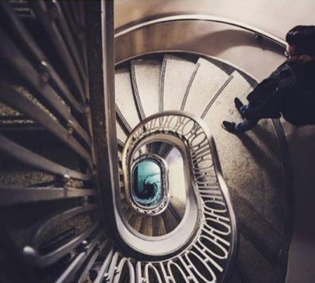 | We are part of @ChiArchitecture's Open House Chicago—a free architecture festival, Oct 15-16. #OHC2016 Learn more: http://openhousechicago.org  Photo cred: John Hill Photography | We are part of @ChiArchitecture's Open House Chicago—a free architecture festival, Oct 15-16. #OHC2016 Learn more: http://openhousechicago.org  Photo cred: John Hill Photography

Week 5 | Facebook | Twitter | Instagram
Monday  9/26 | Did someone say FREE? We are offering complimentary hot breakfast to all those staying with us. Don’t have time to sit down and eat? No problem! We have On the Run breakfast bags available during the week for guests to grab on the go.  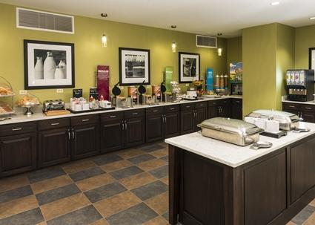 | Did someone say FREE? We are offering complimentary hot breakfast to all those staying with us. Don’t have time to sit down and eat? No problem! We have On the Run breakfast bags available during the week for guests to grab on the go. | Did someone say FREE? We are offering complimentary hot breakfast to all those staying with us. Don’t have time to sit down and eat? No problem! We have On the Run breakfast bags available during the week for guests to grab on the go.
Wednesday  9/28 | Looking to stay fit on your trip to the Windy City? We have the solution for you. With our hotel’s fitness center and recreation room, guests will be able to work out during their stay at the hotel.  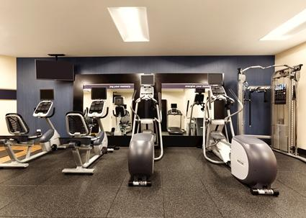 | 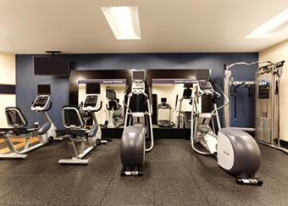  Looking to stay fit on your trip to the Windy City? We have the solution for you. With our hotel’s fitness center and recreation room, guests will be able to work out during their stay at the hotel. | Looking to stay fit on your trip to the Windy City? We have the solution for you. With our hotel’s fitness center and recreation room, guests will be able to work out during their stay at the hotel.
Friday  9/30 | @ChiArchitecture's free Open House Chicago festival is Oct 15-16. Visit our building! #OHC2016 Learn more: http://openhousechicago.org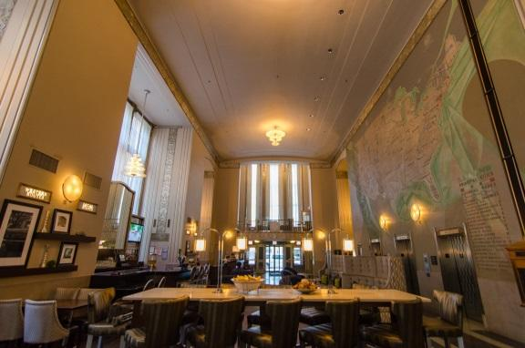 | @ChiArchitecture's free Open House Chicago festival is Oct 15-16. Visit our building! #OHC2016 Learn more: http://openhousechicago.org | @ChiArchitecture's free Open House Chicago festival is Oct 15-16. Visit our building! #OHC2016 Learn more: http://openhousechicago.org

